Assignment 1:

Write automation script for connecting android device and capture the session Id for connection.

Solution:

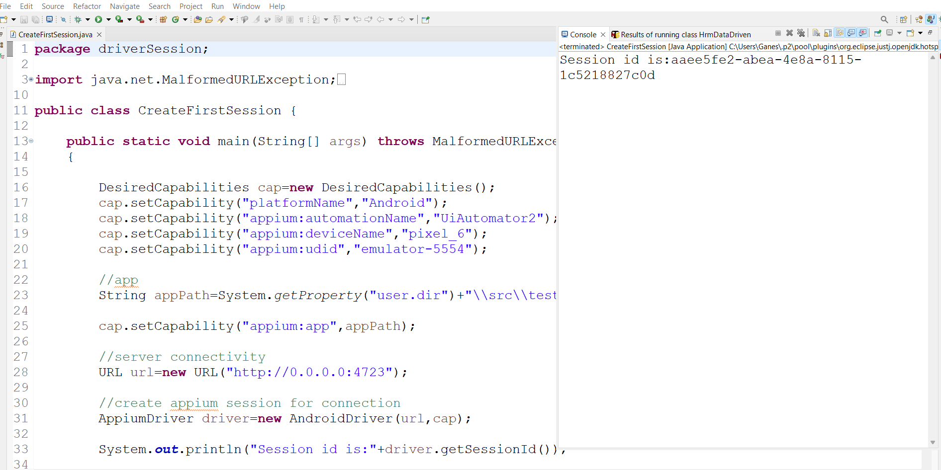

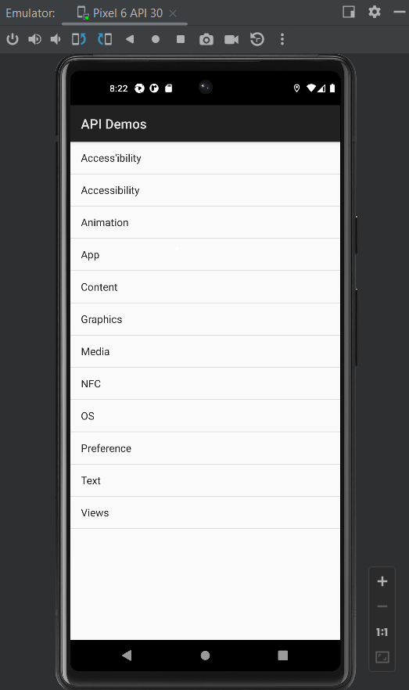

Assignment No 2:

Write automation script for launching mobile application

1. test the application current state(queryAppState)

2. Send application in background and the again capture the state.

3. Uninstall the app (any sample app)

4. Install the app using command

Solution:

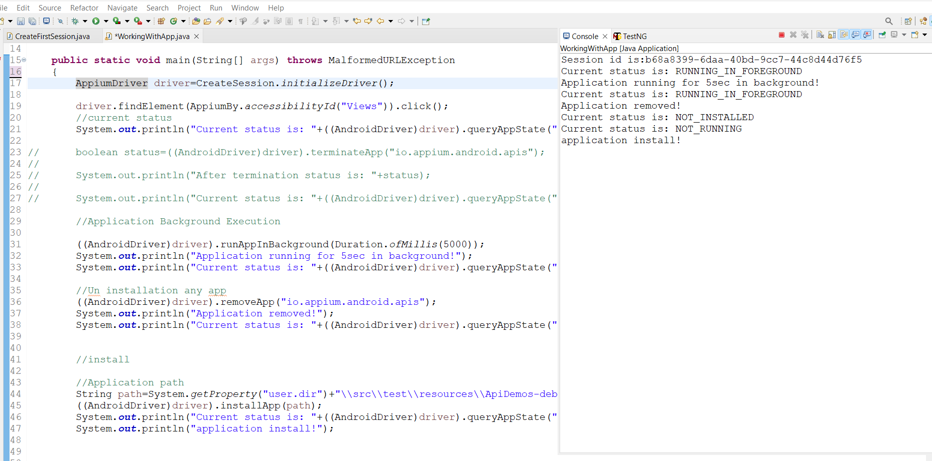

Assignment No 3:

Write automation script to open APIDemos application on Mobile device

Goto view and perform drag and drop functionality.

Solution:

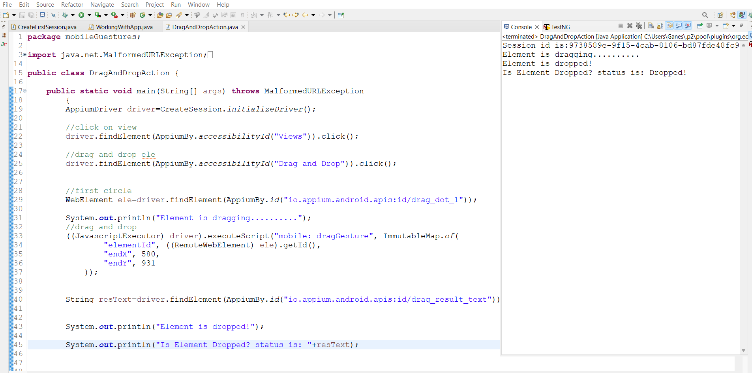

Assignment 4:

Write automation script to open APIdemos application

and capture the screenshot.

